HomeWork 3

Due Date: Wednesday 3/31/2021
HW Delivery: submit on Canvas by the due date, before midnight
Total Points: 60

General Rules: Create homework, compose specifications or any text by using a common document-creation tool, such as Microsoft® Word. Each question is worth 3 points.

Detailed hints: Refer to the wwweb or lecture notes for this class to answer the questions below. Be concise, complete, and precise.

1. Explain precisely and in detail: what is an algorithm.
An algorithm is a series of instructions or rules that a program follows to produce a set of information based on data inputs, limits, user preference, etc.

2. State in detail key attributes of a “good system programmer”. Why are they necessary?
Some key attributes of a good programmer include:
- Excellent communication skills to most effectively achieve the intended goal.
- Make code as human readable as possible and parenthesize wherever possible.
- Being as adaptive as possible to accommodate any situation.
- Make future-proof and maintainable software.

3. List at least 5 key attributes that production SW of true value should possess. What is the consequence for the SW if some attribute is missing.
a) Ease of access for the client/user.
b) Simple to read/edit for the developer.
c) Future-proof, well-documented, and maintainable for future developers.
d) Should serve exactly the intended purpose.
e) Programmed defensively to prevent both user and programmer errors.

4. Sketch in simple English Linear Search, Binary Search; outline, when is it prudent to use either in actual programming?
Linear Search: Does not make any assumptions and simply searches chronologically forwards or backwards in a list/array of information. It’s most practical to use this search algorithm when trying to find if a piece of data does not exist within a list.
Binary Search: Assumes that the array/list is already sorted and that its elements are unique/non-repeating. The search sorts through the first half of a data structure and eliminates unnecessary information from its queue thus increasing efficiency. It’s most practical to use this search algorithm when trying to narrow down a single element in an organized structure.

5. What is the cost for a linear search in Big-O notation; what is the cost for a binary search? When does binary search work?
The cost for a linear search in Big O notation is O(n). The cost for a binary search is O(log₂(n)). Binary search works when the data structure being searched is pre-organized/sorted.

6. List key programming considerations when searching for an element in a graph G. Consider unconnected graphs. Consider multiple occurrences of a datum; cycles in a graph.
Edges can be directed or undirected, so a simpler way to search is to view undirected edges as bidirectional. Any node within graph G can have very many incident edges so it’s important to accommodate for unexpectedly large values.

7. Use Big-O Notation to characterize the computational cost of algorithm A1 and A2. The complexity of A1 is 10000 * n, with n being the number elements processed in A1. The complexity of A2 is 100 * n, with n elements in A2. Also, state in Big-O notation the cost of f1, with f1(x) = log2(2x) – 14x + 3 sqrt(x) + 12x² - 150
SKIP

8. Convert decimal 123456 to binary, octal, and hexadecimal. Convert hex 0xffff to binary, octal, and decimal.
123456:
Binary: 11110001001000000
Octal: 361100
Hexadecimal: 1E240
0xffff:
Binary: 1111111111111111
Octal: 177777
Decimal: 65535

9. Are any of the below sets A, B, C, D equal? If so, list which ones are. Argue why:
A = { red, blue, pink, brown, yellow }
B = { orange, yellow, purple, orange, purple }
C = { red, brown, yellow, green, blue }
D = { orange, purple, yellow }
Sets B and D are equal. Though they contain repeating elements and are organized differently, both contain the same elements.

10. Briefly sketch an algorithm that describes how one can be guaranteed to become very rich.
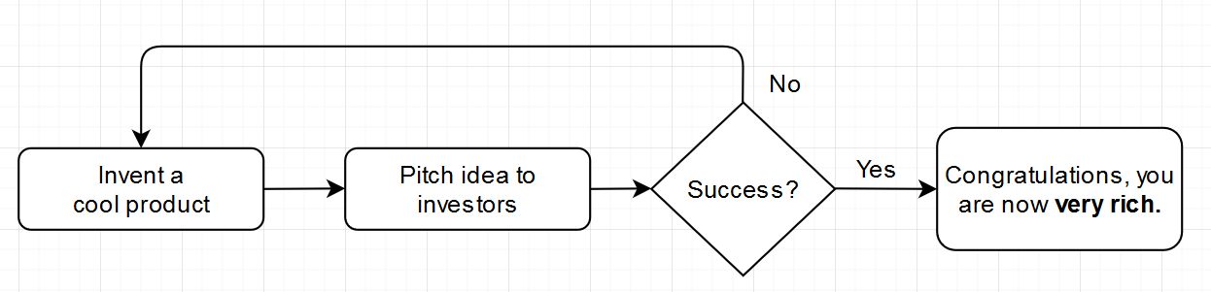

11. State key reasons, why generally product SW is developed in a high level language. Why not use assembly language? Which language would generally be more efficient?
Software is developed using high-level languages because it’s much more human-readable than low-level languages like assembly. While coding in assembly gives you complete control over the CPU, it’s an extremely slow development process that would take far too long when coding larger projects.

12. What is essential about “defensive programming”? Will it create overhead? Always?
Not only should you program error catching for the user, but also for your own software in the event some unforeseen bug arises. Prepare for any kind of error or unusual situation both client-side and developer-side.

13. Name and briefly explain several topics of Discrete Mathematics.
Graph Theory: The study of graphs used as mathematical structures to model relations between functions and objects. Use of nodes, points, edges, and vertices.
Set Theory: The study of sets as collections of objects. Organized/unorganized groups of data.
Number Theory: The study of integers and their related functions, primarily prime numbers.

14. Describe or define: Compound Proposition.
Compound propositions include conjunctions, disjunctions, conditionals, and biconditionals. A compound proposition consists of combinations of 2 or more of these elements and can be expressed through truth tables.

15. Define Empty Set, Singleton Set, Cardinality of Set, Power Set, and Universal Set. What is problematic about “Universal Set”?
Empty Set: A declared set containing no elements.
Singleton Set: A set containing a single element.
Cardinality of Set: The number of unique elements within a set.
Power Set: The power set P(S) containing all subsets of set S, the empty set, and set S itself.
Universal Set: The set U containing all known information in a field. One issue with the universal set is that it tends to be ambiguous in certain cases.

16. Outline a plausible way (or generic data structure) for implementing the data structure Set in a Programming Language. Is it hard or practical? Costly or efficient?
To implement sets, recursion is the first issue that needs to be restricted. While 2^{n} does not seem like a large number when starting at 0, exponential growth gets extremely large quite fast. There would need to be a limit on how large n should be to prevent ludicrous amounts of sets from being produced. To implement into a compiler, I would tokenize every set or resulting set beginning with ‘{‘ and ending with ‘}’ (with commas tokenized as separators) and screen n in case the number is far too large.

17. What is Logic? Where and why is logic used in CS?
Logic is the use of validation and verification to achieve an objective truth based on fact. Logic is what every electronic device uses to function, whether it’s a computer or a simple light bulb. It’s used in Computer Science because it helps us advance our current understanding of technology and prove if certain feats are possible or not.

18. Characterize Tautology and Contradiction.
A tautology is when something is double-stated or repeated unnecessarily. One example might be: “He lived in one singular apartment” where one and singular both mean the same thing. A contradiction is a direct fault of one’s own statements by way of fact or further revealed information. One example might be: “The suspect was clearly wearing a blue shirt with an eagle on the day of the trial” when it was the victim was wearing this shirt – not the suspect. Basically, a contradiction is proving yourself wrong.

19. Given Boolean variables P and Q, is this equivalence ↔ true? ¬(P^Q) ↔ (¬P) v (¬Q)
P |  | Q |  | ¬(P ∧ Q)
F |  | F |  | T
F |  | T |  | T
T |  | F |  | T
T |  | T |  | F

P |  | Q |  | (¬P) ∧ (¬Q)
F |  | F |  | T
F |  | T |  | F
T |  | F |  | F
T |  | T |  | F
Based on the provided truth tables above, the equivalence is not true.

20. Describe the term ordered n-tuple”. Is an n-tuple a set? When are 2 distinct n-tuples equal?
An ordered n-tuple is an arranged collection of n objects combined into one element and is not defined as a set. Two distinct n-tuples are equal if both contain the same elements and are organized in the same order.

